16-Strategy Pattern

- Imagine you have one task, but there are many ways to do it.
- យើងបង្កើតវាដើម្បីជំនួសដោយប្រើ else if ច្រើនទៀត
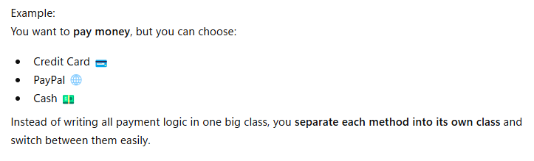

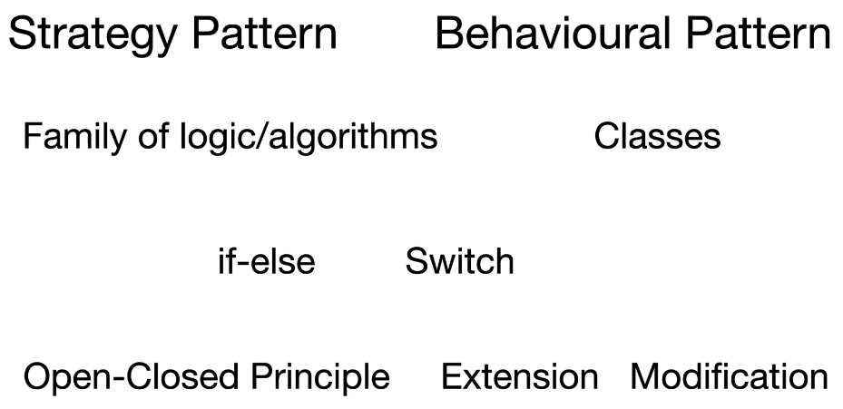

- Problem if we don’t have strategy Pattern

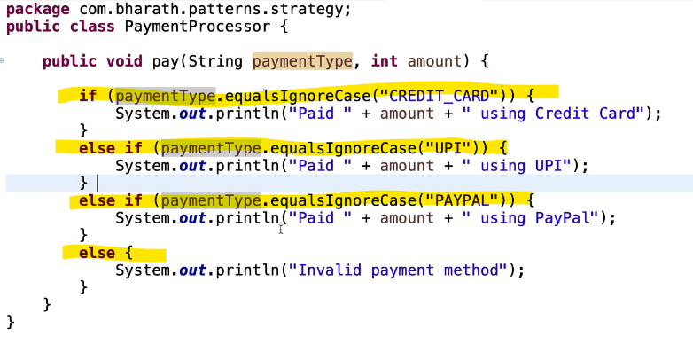

Implementation :
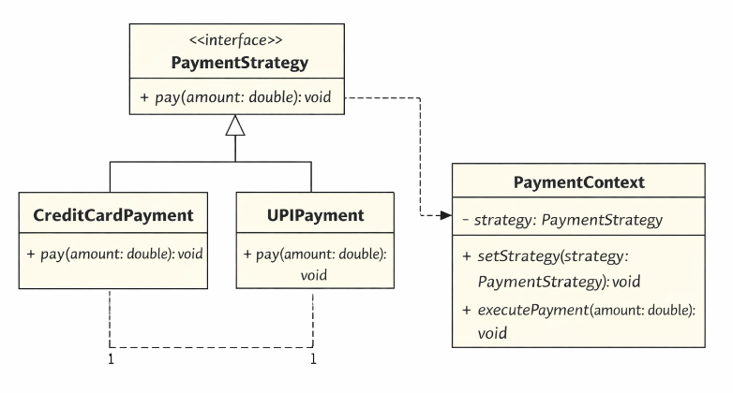

- Create interface

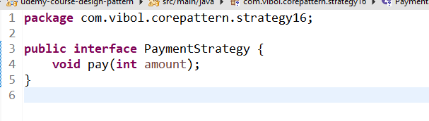

- Payment context
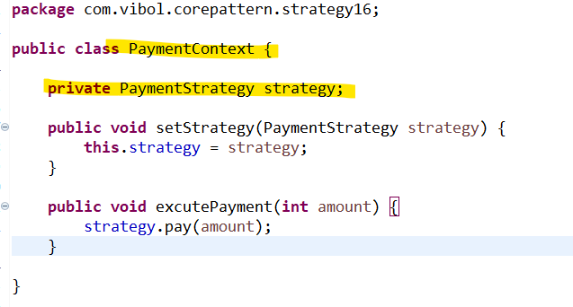

- Implementation
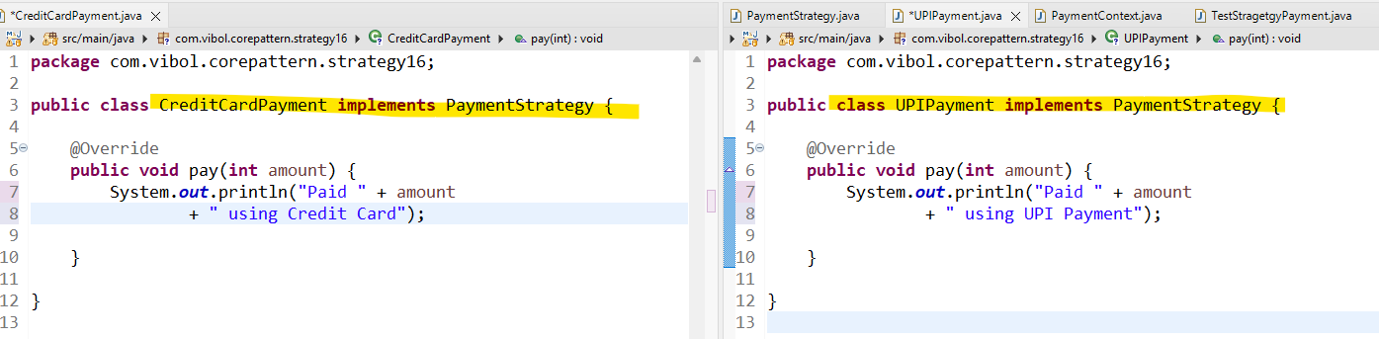

- Testing

